
FedEx campaign project


Ritika Bhadoo
Brand story telling
Thursday 8:00am
December 7, 2023
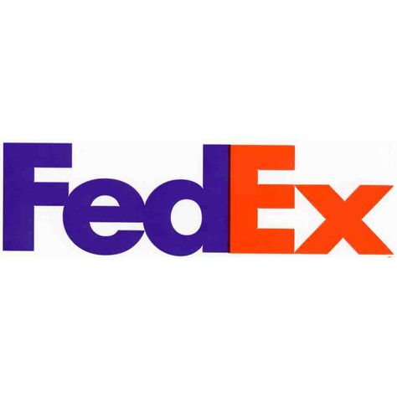

CREATIVE BRIEF
Client: FedEx
Product: FedEx express
Media: Outdoor and Radio
Date: December 7, 2023
Objective: To increase number of customer who is using FedEx services to gain more profits
Target Audience: Jennie and Henry from Australia are the parent of Pery who is living in Canada. Pery is 25 and is living is Toronto and have HHI of $123,000. On Christmas her parents want to send her gifts because she is far from home and they are missing her. All the companies take at least 15 days because it is busy season to deliver parcel. After a research they found FedEx express services.
Main Message: With FedEx express services you can send thing faster and save the things from being damaged. Give your love to your loved ones this festive season.
Tone and Manner: emotional and lighthearted
Slogan: FedEx: Where quality meets speed

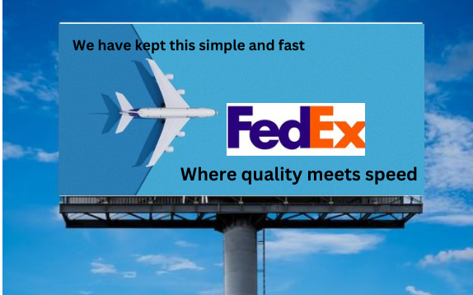
Traditional outdoor ad

The speed of the service is very fast so FedEx is giving competition to other companies and the quality FedEx offered is great.

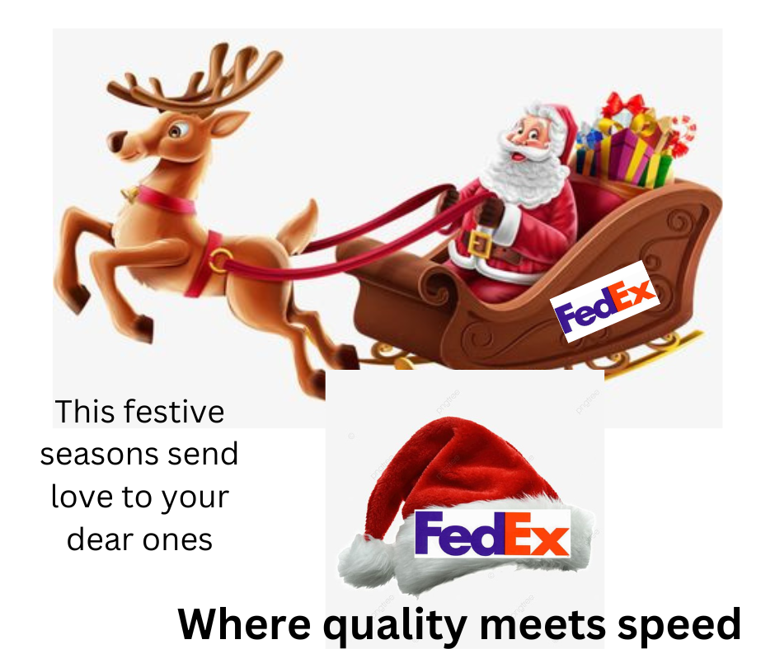
Non-traditional ad
Make your life easy fill your heart with joy because FedEx is here to help you to deliver your blessing to you close people in a fast pace.

RADIO SCRIPT
Client: FedEx
Product: FedEx express
Media: :60 Radio
Title: where quality meets speed
Date: December 7, 2023
Trin trin doorbell ringing
Jerry: Yes who’s this?
Deliver boy: Parcel for you?
Jerry: Wow such a huge parcel, tom help me please. My parents are missing so they send me Christmas gifts. I’m excited to get but the services are really fast. FedEx delivered the parcel in just two days, and everything is safe really FedEx is where quality meets speed.
Tom: Yes, my friend I’m happy for you. FedEx helps to connect the families and make their bonds stronger.
Jerry: why are you so sad what happen.
Tom: Christmas is coming and I’m missing my family and their blessing. I hope I will also get something from FedEx.
Jerry: Don’t worry you will get it. Smile merry Christmas.

